DIVISION

TEMPLATES AND GUIDESFG

SLA's are critical to network monitoring, infrastructure testing in support of services, and can additionally be used to automated network reconfigurations. Their value cannot be underestimated but Network Administrators must realize that as with most network management tools, the very act of testing systems affects the environment under test. Care should be taken to limit the intrusiveness of network monitoring; SLA's being only one of these.

Orion NTA is capable of tracking SLA's that have been configured on network devices (given that they are SNMP manageable). This is the preferred method to institute SLA's. This as opposed to instantiating them on the SNMP manager itself; which would be less desirable because typically the SNMP manager station is outside of the typical traffic flow path (in its entirety), so results are less accurate than an SLA configured in-line on a device directly on the path.

1. The SLA in question should already be configured and scheduled on the network device in question.\

**(THIS IS AN EXAMPLE SLA ONLY - IT WILL NOT MATCH STUDENT SLA'S)**

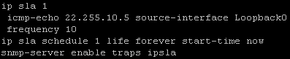

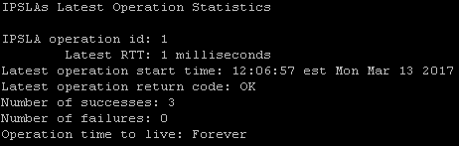

2. Access your Orion server and Navigate to the "Voip & Network Quality" Tab.

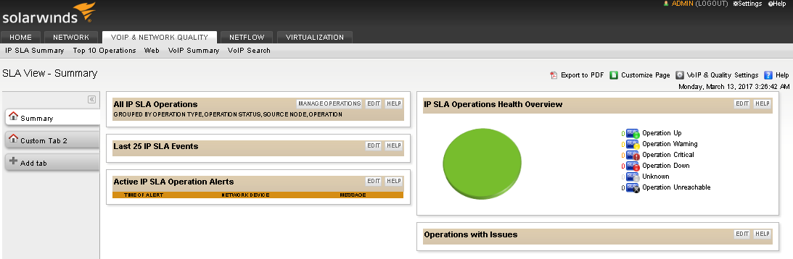

3. You may have to re-poll your student router in order for Orion to realize the SLA capabilities already configured there; to do so: Click "VoIP & Quality Settings" at the top right.

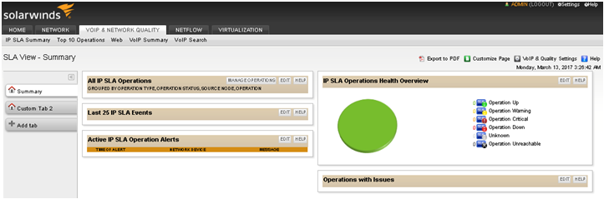

4. Select "Automatically Discover IP SLA capable nodes.

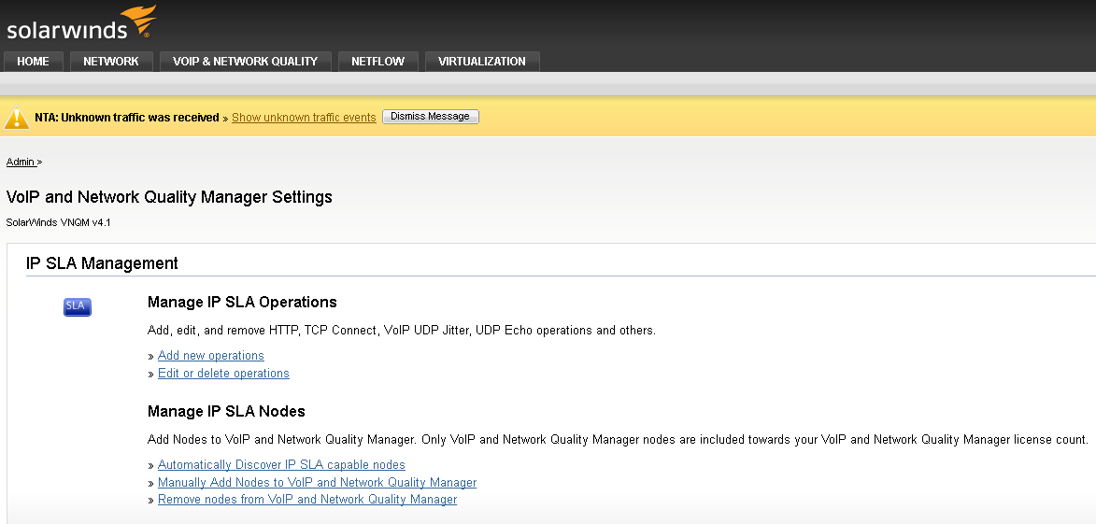

5. Select "START IP SLA DISCOVERY"

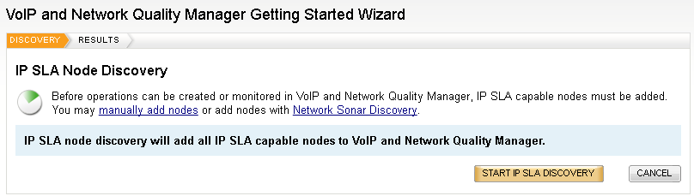

6. A pop-up window similar to the following will appear:

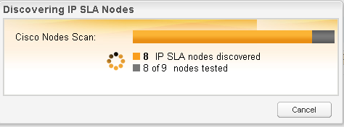

7. Exit the wizard.

8. Click "Manage Operations" in the "All IP SLA Operations box.



9. Click "Add New IP SLA Operation"

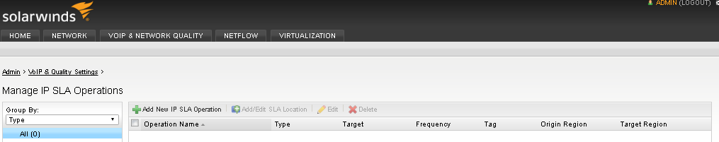

10. You should now be at the "IP SLA Operations Wizard", Under "I would like to:" select the radial button for "Monitor existing operations" and click "NEXT."

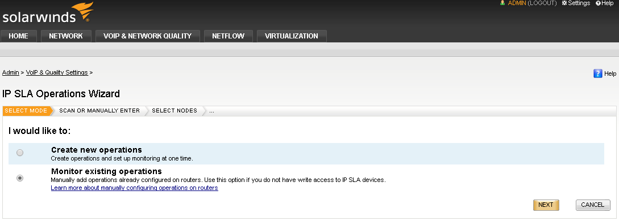

11. Under the IP SLA Operations Wizard, and the question "How would you like to add existing operations?" Select "Automatically discover existing operations" and then click NEXT.

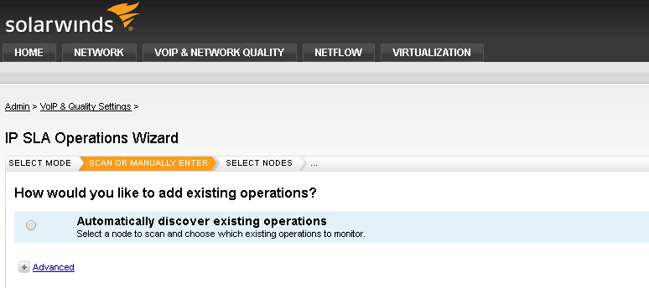

12. Expand the "+" symbol to view different SNMP monitored devices. Click the blue "all" hyperlink, and then click "NEXT"

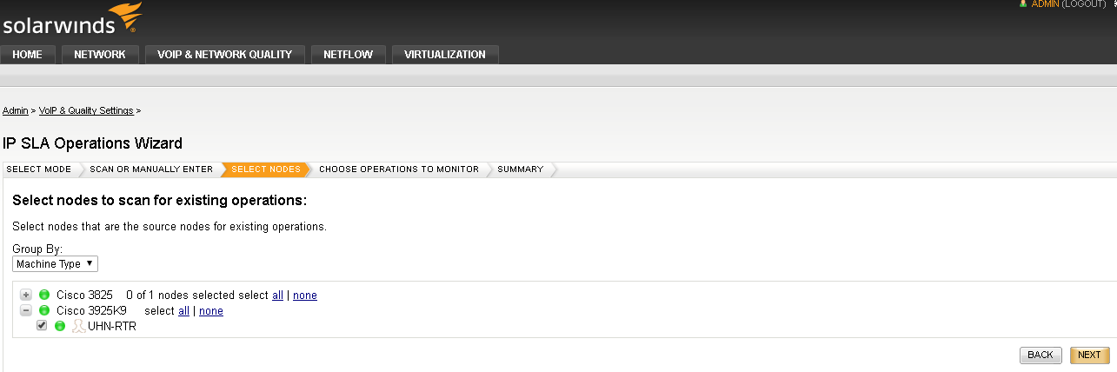

13. A window will appear:

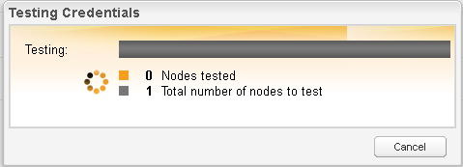

14. Under the "Choose Operations to Monitor" Select the device and operation you wish to have Orion monitor. Then click "MONITOR OPERATIONS"

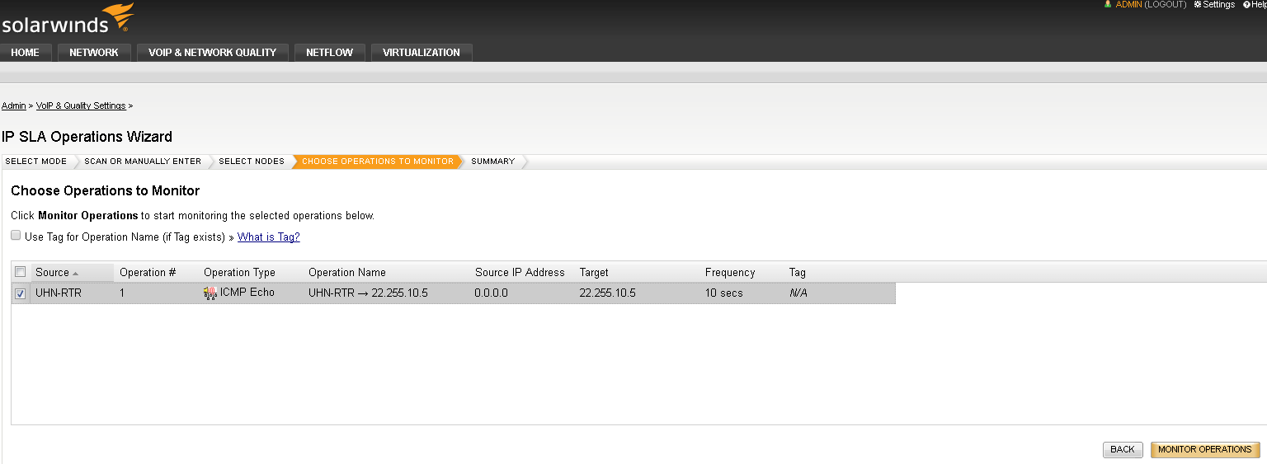

15. A summary will be shown of operations that will be monitored. You can now return to the "VOIP & NETWORK QUALITY" tab directly or by selecting "GO TO VNQM HOME" and select the "+" symbols to expand and view the state of the monitored SLA operation.

